1) Any 3 best practices of docker?
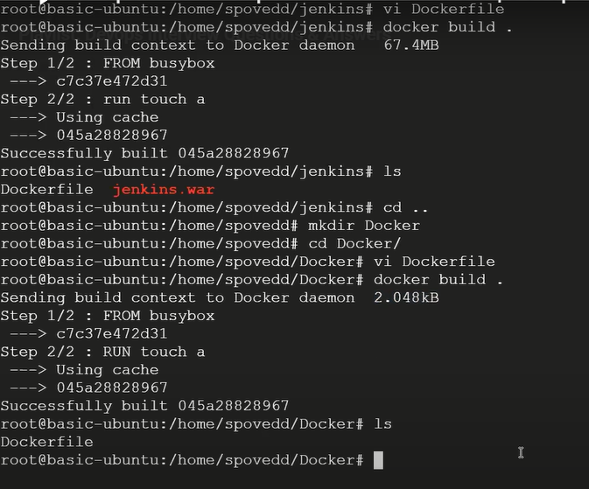

It will try to send what are the files in the directory to docker daemon so unnecessary size is added
* Be specific in the tag if you provide latest, after three to 4 months the latest version is changes from 8 to 9
* use always official images rather installing debian image and installing jdk on that and running your application, just take openjdk image and run your application you can take off unnecessary image layering and memory utilization will be less
* multistage build also reduces the size of the image

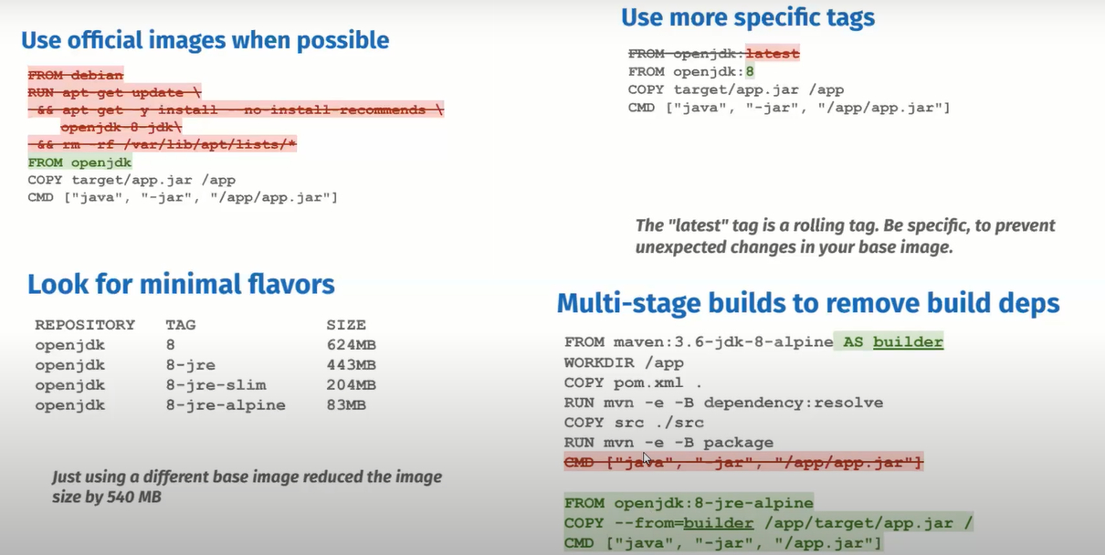
2) Difference between docker stop and docker kill?
Both command is used for stopping your container 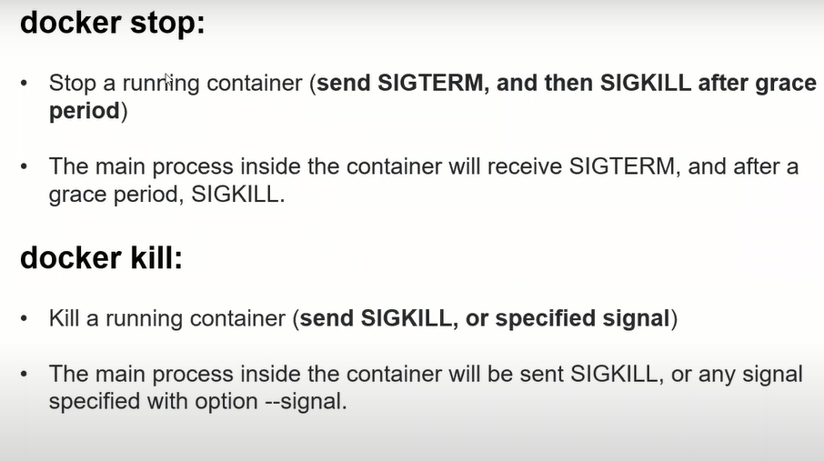
When you create a busybox image docker run –d –it busybox /bin/sh and docker stop containerid and see in the docker events
(It sends two kind of signal first signal 15 and it will give 10 sec of grace period meanwill it will take time to finish that work, then signal 9 kill the container forcfully)
If you try to stop it from docker kill containerid in docker events
(It don’t provide the grace period directly send signal 9 to kill container forcefully)
3) Command to list conatiners which state is exited? ( docker ps –a)
-f = filter 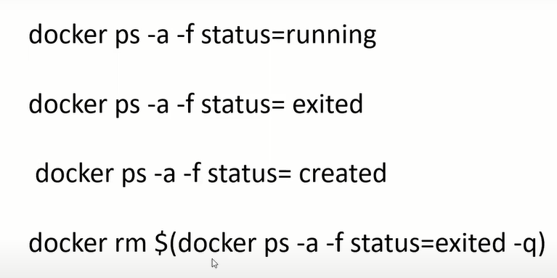
4) command to clean-up docker host ( deleting stopped conatiners, dangling images and unused networks)? 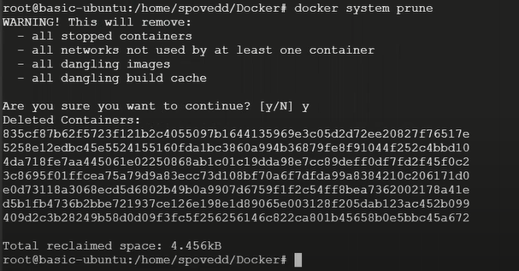
5) What version of docker you have used? Specific reason to use that particular version?
6) Can we have multiple CMD in Dockerfile?
You can have it, but no use because if you have multiple CMD only last CMD will be taken into account
7) Have you worked on docker swarm and docker compose?
Docker swarm is similar to kubernetes it Is a group physical server or virtual machines that run in docker application if you want to configure as a cluster and if you want to orchestret your container then you go with docker swarm
Where as docker compose is multi-container aplication like mysql database or someother application that time you give with this 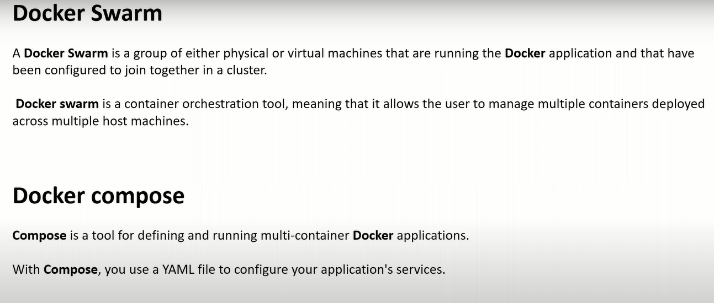
8) Have you worked on multi-stage dockerfile and why we need that?
To reduce the image size you go for multistage docker file repo—(Java_Multistage_dockerfile→Dockerfile)
I have a code in my local what I want to do is I want to copy the that local code on to my container I need to do mvn install so then In that container what should have is maven and also the tomcat. So once the maven install is done I gone a get the war file right I need to transfer that war file to tomcat in that case we deel this thing in many case centos as base imgae on top you can install maven and tomcat but image size increses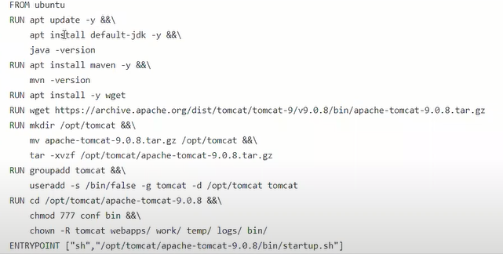 to avoid this we can go for multistage docker file 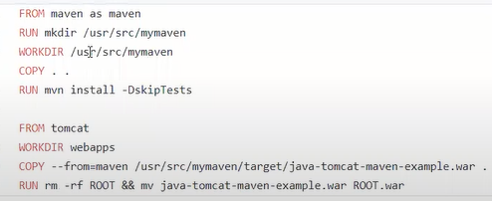here I am using 2 base images (2 from) what it does exicute all the steps from the first from then all this thing will move to docker cache from docker chache I am reffering that war file and I am placing it in webapps file now my image size is consider on base image of tomcat
9) can you copy a file form local to run container?
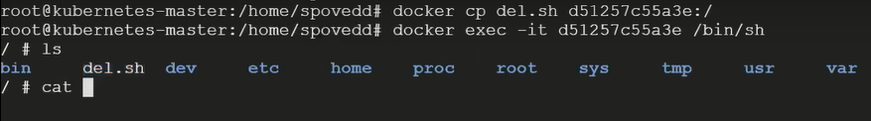
10) Lets say i have container which is attached with a volume, if container crashes what happens to volume?
In that case volume won’t be deleted
I not runing in deamon mood directly I am inside container and the container is not in running state check with docker ps it will present in docker ps –a we have volume attached for it won’t be deleted by default untill explicitly user delete that volume 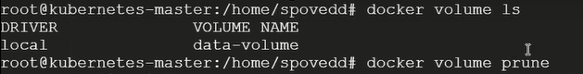once the container is deleted you can delete the volume
11) Lets say I have 1 GB file that has to be sent to docker daemon, as its 1GB it will take muchtime and network too. By which option while building dockerfile we can send the fileIn better manner? 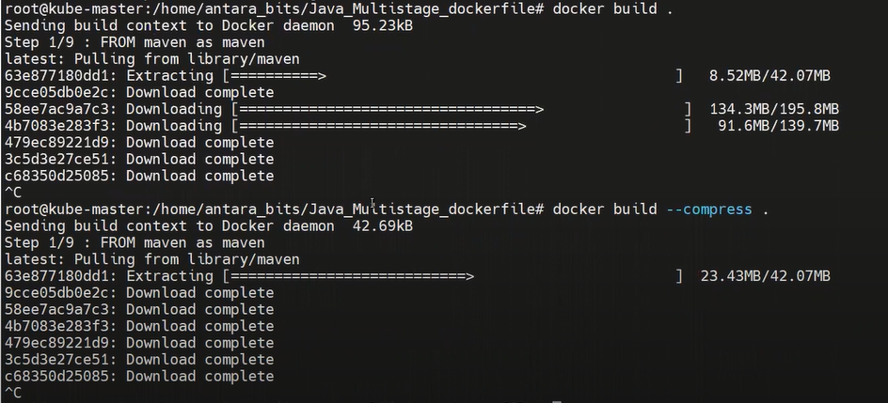
12) What is the difference between ADD and COPY docker instructions in Dockerfile? 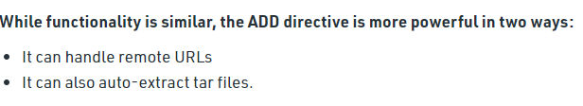 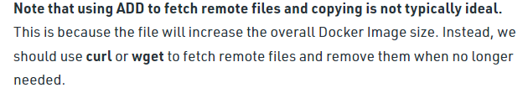
13) Command to remove, stopped and running Containers?
To get the list of both stopped and running container (-q only disply container id)
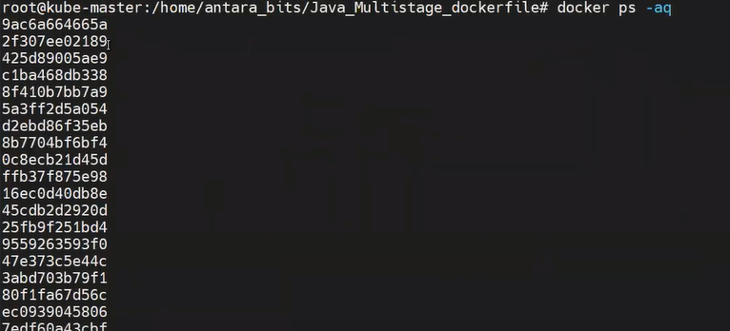
To stop this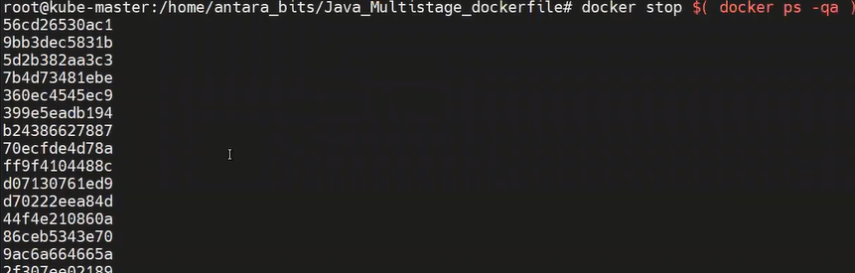to remove this
If you want to delete only stopped container then 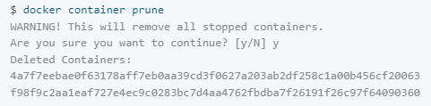
14) Inside the container I did many changes like Creating, modifying and deleting file but I Wanted to check which files has been changed And what action has been taken what is the Command we need to use ?
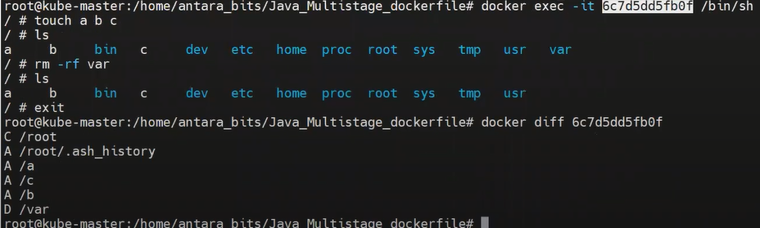C- change A-added D-deleted
15) How to configure docker private registry?
(Repo—CICD_Java_gradle_application→wiki→ Creating Docker hosted repository in Nexus and pushing the docker image through Jenkins) countinue

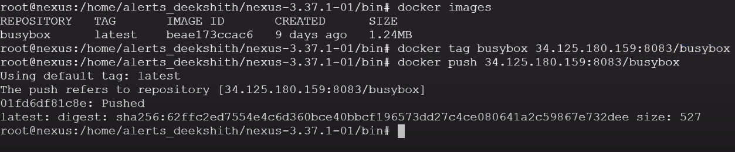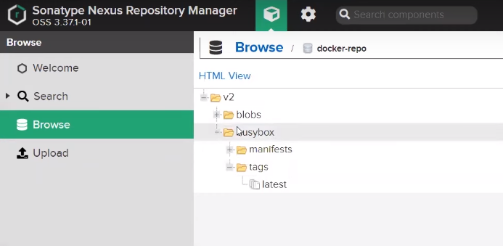

16) Types of network in docker? if you dont specify network to deploy on which network the conatiner will be created?
There are three common Docker network types – bridge networks, used within a single host(it will ceate a isolated network interface to your container itself), overlay networks, for multi-host communication, and macvlan networks which are used to connect Docker containers directly to host network interfaces.
Most commanly used bridge,null & host network
Host network – it will not create a isolated network it will be with your host machine network itself. (When you are working with some monitering applications & where you want to get the infromation about processes which are running on host machine in that case we go for host network)
Null network—when your working with some virus or mulware related project you don’t need any assoicition with host network in that cases you go with null network
At the time of creating container if you don’t specify it will take default bridge network

17) Explain a sample dockerfile that you have used in your project?
Video – 1:40:33 (4 min)
18) Can we launch linux conatiners windows and viceversa?
You can’t launch windows container an linux or linux container on windows because docker architecture work on host OS that’s the reason diff OS container can’t be hosted and any other machine (linux host OS is completely diff then windows OS) 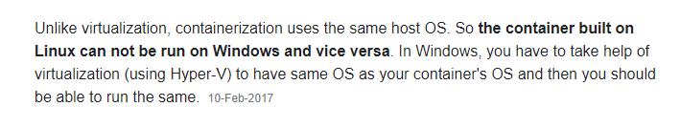
19) What does ONBUILD instruction do in Dockerfile?
Onbuild-python-app → Dockerfile-parent 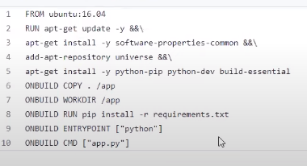
(Trigger the instruction at the later time when the image is used as base image in another build)
which ever the instruction in front of unbuild it won’t be exicuted when you create the image let’s assume run the docker build and create the Image called python-parent in that case this instruction won’t be exicuted once the image is created and if python-parent is base image of any other docker file

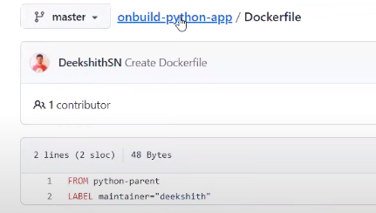
In this case what ever the onbuild instruction mentioned is going to executed when I use this python-prent image as base image in other docker file
This ONBUILD play important rule – let’s assume have a 50 project all the 50 project uses same docker file rather than keeping this docker file in each repository by using ONBUILD you can create dockerfile like this and you can create image out of this and use this as parent image or base image. Like if you want to change anything across all the project you can change it here so maintenance will be easy
20) What is the use of .dockerignore file?
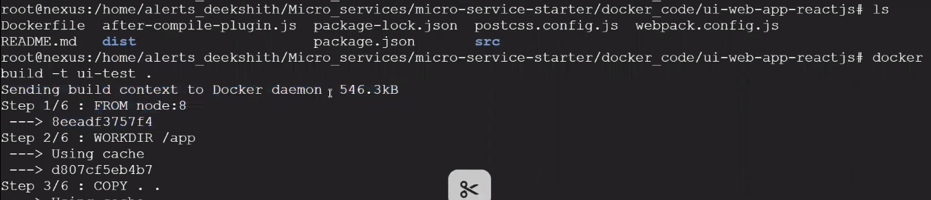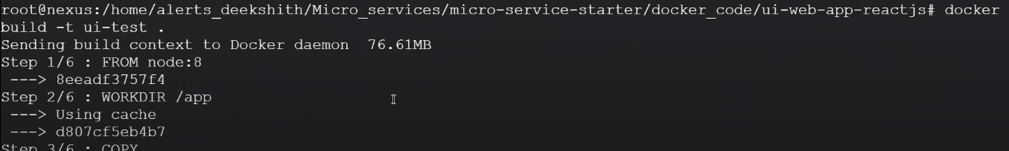
Create vi .dockerignore file place the file name which you wan to ignore (jenkins.war) and build the image now the docker deamon size is reduced to 550kb
21) I need to delete all stopped containers and unused images command for that?
To delete only stopped container
You want to delet unused images 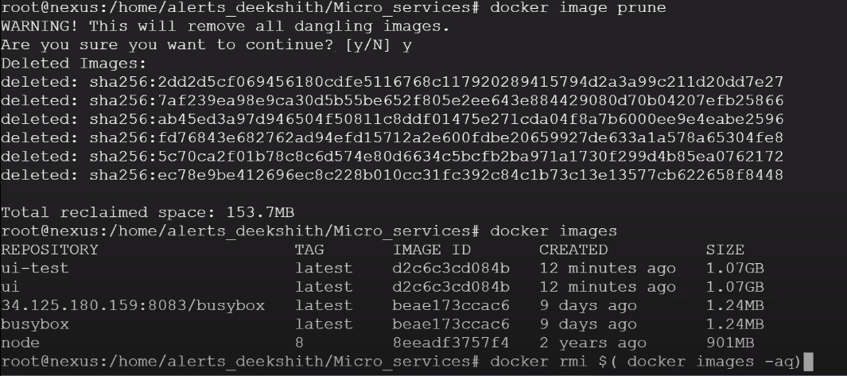
22) Is it good to use docker compose in production
No (avaiability and replication is not achived) which is only for dev related activities. Let say you have microservices 3 to 4 services comes up to bring one application in that place building docker file individualy and also taking the image and running docker run command to bring up the container you can use docker compose file where you can give the information about docker file ,docker image, port informaton with a single command you can bring up all this componant that’s where docker compose come into the picture
23) Why we need docker compose and docker swarm
24) What's the difference between docker volume and docker mounting
25) How do you monitor docker in production (techworld with nana)
26) What is the importance of .dockerigonre file, can name docker file with any other name?
27) I have dockerfile that accepts arguments, if I supply value as “1” then it should use maven 2.x version for base image and if I supply “2” then it should take maven latest as base image
28) What are docker compose and docker swarm?
29) Why we need docker compose and docker swarm
30) how parametrize base image tag? 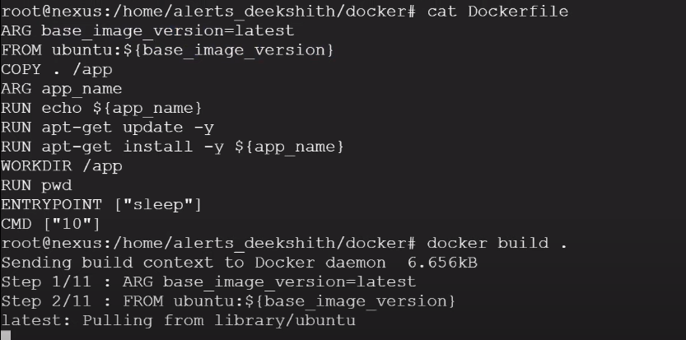 by default it will take latest image
User specify the version of the image
31) Building docker file in a directory which has large file is a good practice?
It is bad practice if do like that the docker deamon size should be more

